


Echoes
Compass Informatics Statement of work
Terraform ARCHITECTURE

Commercial and in confidence
Version 1.0 June 1, 2023

ECHOES

VERSION: 1.0.0 | REVISION DATE: [Date]

Approval of the Terraform Architecture indicates an understanding of the purpose and content described in this deliverable. By signing this deliverable, each individual agrees with the content contained in this deliverable.

Approver Name | Title | Signature | Date

Echoes Technical Architecture Page 1 of 16

Document Scope
This document describes the Terraform Architecture of the ECHOES and implements of infrastructure as code

The goal of this document is to explain and demonstrate how to implement an architecture as code and ensure that the components of the AWS architecture are compliant and comply with the enterprise-wide standards and direction set by the Echoes.

The Document Scope narrative also provides an overview of the efforts conducted to understand the existing technical environment and IT strategic direction and to determine how the system’s proposed technical architecture fits into them.

Overall, of Terraform Architecture
HashiCorp Terraform is an infrastructure as code tool that lets you define both cloud and on-prem resources in human-readable configuration files that you can version, reuse, and share. You can then use a consistent workflow to provision and manage all of your infrastructure throughout its lifecycle.
Terraform creates and manages resources on cloud platforms such as AWS and other services through their application programming interfaces (APIs). Providers enable Terraform to work with virtually any platform or service with an accessible API.

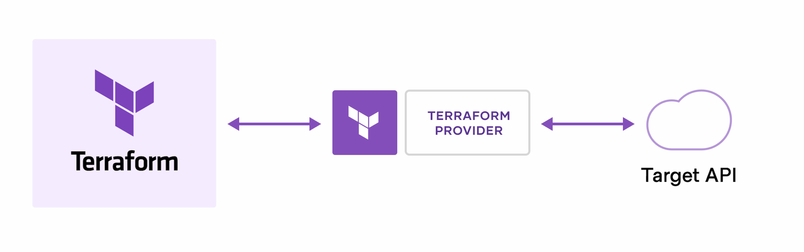
The core Terraform workflow consists of three stages:
- Write: You define resources, which may be across multiple cloud providers and services. For example, you might create a configuration to deploy an application on virtual machines in a Virtual Private Cloud (VPC) network with security groups and a load balancer.
- Plan: Terraform creates an execution plan describing the infrastructure it will create, update, or destroy based on the existing infrastructure and your configuration.
- Apply: On approval, Terraform performs the proposed operations in the correct order, respecting any resource dependencies. For example, if you update the properties of a VPC and change the number of virtual machines in that VPC, Terraform will recreate the VPC before scaling the virtual machines.

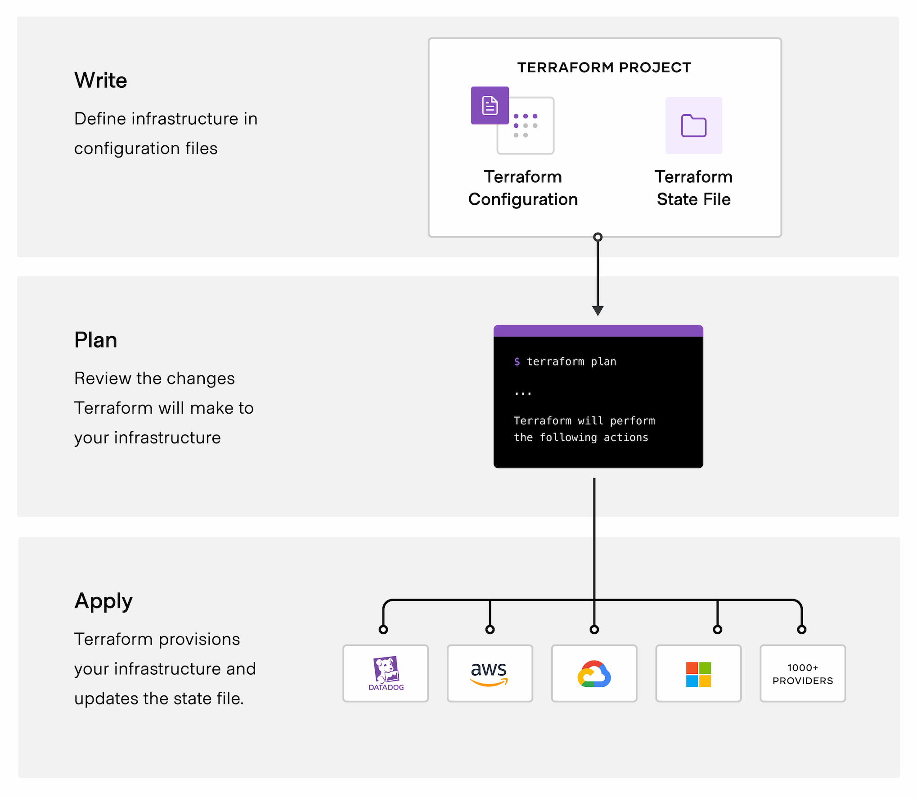

System Architecture Context Diagram AWS hosting - Echoes Overview Diagram

Figure 1. The Diagram show an overview of Echoes process

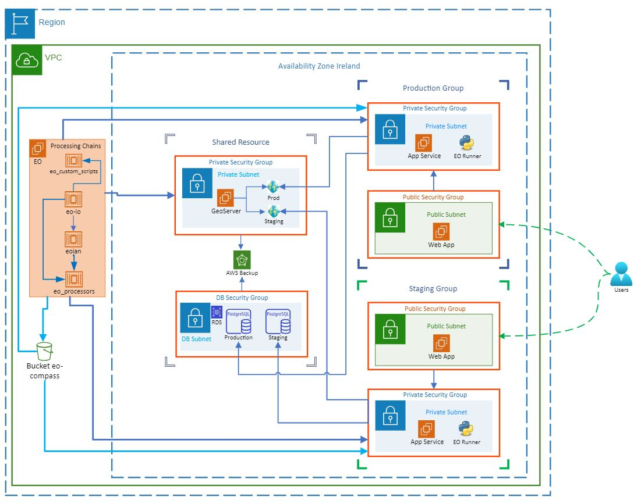

This architecture overview shows all levels of the Echoes system and part of that infrastructure was created through the Terraform using AWS provider as shown below code.

Note: The Geoserver and Processing chains is not included on that documentation.

The first step is to configure the provider with the proper credentials before you can use it.

Configuration for the AWS Provider can be derived from several sources, which are applied in the following order:
- Parameters in the provider configuration
- Environment variables
- Shared credentials files
- Shared configuration files
- Container credentials
- Instance profile credentials and region
- Static credentials

For this code we will use the Static credentials which can be provided by adding an access_key and secret_key in-line in the AWS provider block:

For more authentication sample you can find here https://registry.terraform.io/providers/hashicorp/aws/latest/docs

Create AWS Authentication

provider "aws" {
region = "us-east-1"
access_key = " key provided by AWS "
secret_key = "Secret key provided by AWS "
}

VPC

The entire network architecture of any cloud-based service is based on Virtual Private Cloud. AWS VPCs offer the required network segregation and enable security by efficiently managing aspects like subnets, routing, firewalls, DHCP, etc.

Create a VPC

To begin with, let start by defining our VPC resource in Terraform. To specify a range of IP addresses in a VPC, a CIDR block needs to be provided.

resource "aws_vpc" "echoes_vpc" {
cidr_block = "10.0.0.0/16"
tags = {
Name = "Echoes-VPC"
}
}

Create Gateway

Create Internet Gateway send traffic out to the internet, because we do want to be able to assign a public IP address to this server so that anybody can reach

resource "aws_internet_gateway" "gw"{
vpc_id = aws_vpc.echoes_vpc.id

tags = {
Name = "Echoes-igw"
}
}

Create Route Table

The route table is responsible for enabling the flow of traffic within the VPC. - (this can be optional)

resource "aws_egress_only_internet_gateway" "egress_only" {
vpc_id = aws_vpc.echoes_vpc.id

tags = {
Name = "main"
}
}

resource "aws_route_table" "echoes-route-table"{
vpc_id = aws_vpc.echoes_vpc.id
route{
cidr_block = "0.0.0.0/0"
gateway_id = aws_internet_gateway.gw.id
}
route{
ipv6_cidr_block = "::/0"
egress_only_gateway_id = aws_egress_only_internet_gateway.egress_only.id
}

tags = {
Name = "echoes-rt"
}
}

Create Subnets
VPC exists across all the Availability Zones in a region. While Subnets are associated with a single AZ. The Frankfurt (eu-central-1) region has three AZs, and we need one public and one private
subnet in each AZ as per the diagram.

Firstly, we identify the CIDR ranges to be associated with the six new subnets we need to create.

Public subnet
resource "aws_subnet" "public-subnet-1a" {
vpc_id = aws_vpc.echoes_vpc.id
cidr_block = "10.0.1.0/24"
availability_zone = "us-east-1a"
tags = {
Name = "echoes-public-subnet-1a"
}
}
resource "aws_subnet" "public-subnet-1b" {
vpc_id = aws_vpc.echoes_vpc.id
cidr_block = "10.0.2.0/24"
availability_zone = "us-east-1a"
tags = {
Name = "echoes-public-subnet-1b"
}
}

resource "aws_subnet" "private-subnet-1a" {
vpc_id = aws_vpc.echoes_vpc.id
cidr_block = "10.0.3.0/24"
availability_zone = "us-east-1a"
tags = {
Name = "echoes-private-subnet-1a"
}
}
resource "aws_subnet" "private-subnet-1b" {
vpc_id = aws_vpc.echoes_vpc.id
cidr_block = "10.0.4.0/24"
availability_zone = "us-east-1a"
tags = {
Name = "echoes-private-subnet-1b"
}
}

Anytime we create a subnet, we have to assign to a route table or then they will get assigned to the default route table for the VPC

Public
resource "aws_route_table_association" "echoes_public_1a_assoc" {
subnet_id = aws_subnet.public-subnet-1a.id
route_table_id = aws_route_table.echoes-route-table.id
}

resource "aws_route_table_association" "echoes_public_1b_assoc" {
subnet_id = aws_subnet.public-subnet-1b.id
route_table_id = aws_route_table.echoes-route-table.id
}

Private
resource "aws_route_table_association" "echoes_private_1a_assoc" {
subnet_id = aws_subnet.private-subnet-1a.id
route_table_id = aws_route_table.echoes-route-table.id
}

resource "aws_route_table_association" "echoes_private_1b_assoc" {
subnet_id = aws_subnet.private-subnet-1b.id
route_table_id = aws_route_table.echoes-route-table.id
}

Create Security Groups
Security groups are one of the most important pillars that support VPC security. They are software-defined network firewalls defined inside a VPC that allow or deny traffic to resources based on the inbound and outbound rules.

Security group rule to access the echoes front-end
resource "aws_security_group" "echoes_public_web" {
name = "echoes_public_web"
description = "Allow Web inbound traffic"
vpc_id = aws_vpc.staging_vpc.id

ingress = [ {
cidr_blocks = [ "0.0.0.0/0" ]
description = "HTTPS"
from_port = 443
to_port = 444
protocol = "tcp"
self = false
ipv6_cidr_blocks=[]
prefix_list_ids=[]
security_groups=[]
},
{
cidr_blocks = [ "0.0.0.0/0" ]
description = "HTTP"
from_port = 80
to_port = 81
protocol = "tcp"
self = false
ipv6_cidr_blocks=[]
prefix_list_ids=[]
security_groups=[]
},
{
cidr_blocks = [ "add a ip address who will access the Linux VM" ]
description = "SSH"
from_port = 22
to_port = 23
protocol = "tcp"
self = false
ipv6_cidr_blocks=[]
prefix_list_ids=[]
security_groups=[]
} ]

egress = [ {
cidr_blocks = ["0.0.0.0/0" ]
description = ""
from_port = 0
ipv6_cidr_blocks = []
prefix_list_ids = []
protocol = "-1"
security_groups = []
self = false
to_port = 0
} ]

tags={
Name="echos_public_web"
}

}

Security group rule to access the echoes backend
resource "aws_security_group" "echoes_private_backend" {
name = "echoes_private_app "
description = "Allow Web inbound traffic to backend"
vpc_id = aws_vpc.staging_vpc.id

ingress = [ {
cidr_blocks = [ "add the front end VM IP address" ]
description = "HTTPS"
from_port = 443
to_port = 444
protocol = "tcp"
self = false
ipv6_cidr_blocks=[]
prefix_list_ids=[]
security_groups=[]
},
{
cidr_blocks = [ "add the front end VM IP address " ]
description = "HTTP"
from_port = 80
to_port = 81
protocol = "tcp"
self = false
ipv6_cidr_blocks=[]
prefix_list_ids=[]
security_groups=[]
},
{
cidr_blocks = [ "add a ip address who will access this VM" ]
description = "RDP"
from_port = 3389
to_port = 3389
protocol = "tcp"
self = false
ipv6_cidr_blocks=[]
prefix_list_ids=[]
security_groups=[]
} ]

egress = [ {
cidr_blocks = ["0.0.0.0/0" ]
description = "Allow outbound traffic to postgreSQL"
from_port = 5432
ipv6_cidr_blocks = []
prefix_list_ids = []
protocol = "tcp"
security_groups = []
self = false
to_port = 5432
},
{
cidr_blocks = ["0.0.0.0/0" ]
description = "Allow outbound traffic to GeoServer"
from_port = 80
ipv6_cidr_blocks = []
prefix_list_ids = []
protocol = "-1"
security_groups = []
self = false
to_port = 80
},
{
cidr_blocks = ["0.0.0.0/0" ]
description = "Allow outbound traffic to Geoserver"
from_port = 443
ipv6_cidr_blocks = []
prefix_list_ids = []
protocol = "-1"
security_groups = []
self = false
to_port = 443
} ]

tags={
Name="echos_private_app"
}

}

Security group rule to access the echoes RDS database
resource "aws_security_group" "echoes_db" {
name = "echoes_db"
description = "Allow inbound traffic for the database"
vpc_id = aws_vpc.staging_vpc.id

ingress = [ {
cidr_blocks = [ "add the back end VM IP address" ]
description = " PostgreSQL"
from_port = 5432
to_port = 5432
protocol = "tcp"
self = false
ipv6_cidr_blocks=[]
prefix_list_ids=[]
security_groups=[]
}
]

# egress = {
# from_port = 5432
# to_port = 5432
# protocol = "tcp"
# cidr_blocks = ["0.0.0.0/0"]
# }

tags={
Name="echos_private_app"
}

}

Create a Network interface
Create a Network interface with an ip in the subnet that was created in step 4
resource "aws_network_interface" "web_server_nic" {
subnet_id = aws_subnet.public-subnet-1a.id
private_ips = ["10.0.1.50"]
security_groups = [aws_security_group.echoes_public_web.id]

# attachment {
# instance = aws_instance.test.id
# device_index = 1
# }
}

# 8. Assign an elastic IP to the network interface created in step 7
resource "aws_eip" "one" {
vpc=true
network_interface = aws_network_interface.web_server_nic.id
associate_with_private_ip = "10.0.1.50" #can be a list too
depends_on = [
aws_internet_gateway.echoes-gw
]
}

Create Linux VM for Frontend
Create Ubuntu server and install/enable apache2
resource "aws_instance" "web-server_instance"{
ami = "ami-01cae1550c0adea9c"
instance_type = "t2.medium"
availability_zone = "eu-west-1a"
#key_name = "TerraFormUser"

network_interface {
device_index = 0 #first network interface associated with this device
network_interface_id = aws_network_interface.web_server_nic.id
}

#here we gonna tell terraform to on deployment of this server to actually run a few commands on the server so that we can automatically install Apache
user_data = <<-EOF
#!/bin/bash
yum update -y
yum install -y httpd
systemctl start httpd
systemctl enable httpd
INTERFACE=$(curl -s http://169.254.169.254/latest/meta-data/network/interfaces/macs/)
SUBNETID=$(curl -s http://169.254.169.254/latest/meta-data/network/interfaces/macs/${INTERFACE}/subnet-id)
echo '<center><h1>This instance is in the subnet wih ID: SUBNETID </h1></center>' > /var/www/html/index.txt
sed "s/SUBNETID/$SUBNETID/" /var/www/html/index.txt > /var/www/html/index.html
EOF

tags={
Name="web-app-echoes",
Environment = "staging"
}
}

Create Windows VM for backend
Create Windows server
resource "aws_instance" "app-server_instance"{
ami = " ami-07fc612d98a90981b"
instance_type = "t2.large"
availability_zone = "eu-west-1a"
#key_name = "TerraFormUser"

security_groups = [aws_security_group. echoes_private_backend]

tags={
Name="app-service-echoes",
Environment = "staging"
}
}

Create RDS
resource "aws_db_subnet_group" "echoes_db_subnet" {
name = "db-subnet"
subnet_ids = [
var.echoes-public-subnet-1a,
var.echoes-public-subnet-1b
]

tags = {
Name = "db_subnet"
}
}

resource "aws_db_instance" "echoes-rds-db" {
identifier = "echoes"
db_name = "echoes"
instance_class = "db.m6i.large"
allocated_storage = 100
engine = "postgres"
engine_version = "13.7"
skip_final_snapshot = true
publicly_accessible = true
db_subnet_group_name = aws_db_subnet_group.echoes_db_subnet.name
vpc_security_group_ids = [aws_security_group.sg_echoes_db.id]
username = "postgres"
password = "Add password"
}

